|  |
| --- |
| Colmq2 (1).jpgégio Jardim Getsêmani  Name:______________________________________ Year: 1º value: 10,0  Teacher: Luciana Fialho Date: __/__/2020 Bimestre: 4º  **Prova Inglês 4º Bimestre ( 1º Ano)**   * Leia atentamente os comandos de cada questão antes de respondê-las; |
| |  | | --- | | **Questão 01** – **1,0 cada do item = valor total = 1,0** | |

1. **What’s your name?**
2. My name is Mario.
3. I’m 37 years old.

|  |
| --- |
| **Questão 02** – **1,0 cada item = valor total 1,0** |

1. **Look the picture ! Circle the correct option.**



1. Good afternoon.
2. Good night.
3. Good morning.

|  |
| --- |
| **Questão 03** – **1,0 cada item = valor total 1,0** |

1. **Look! This is my ____.**

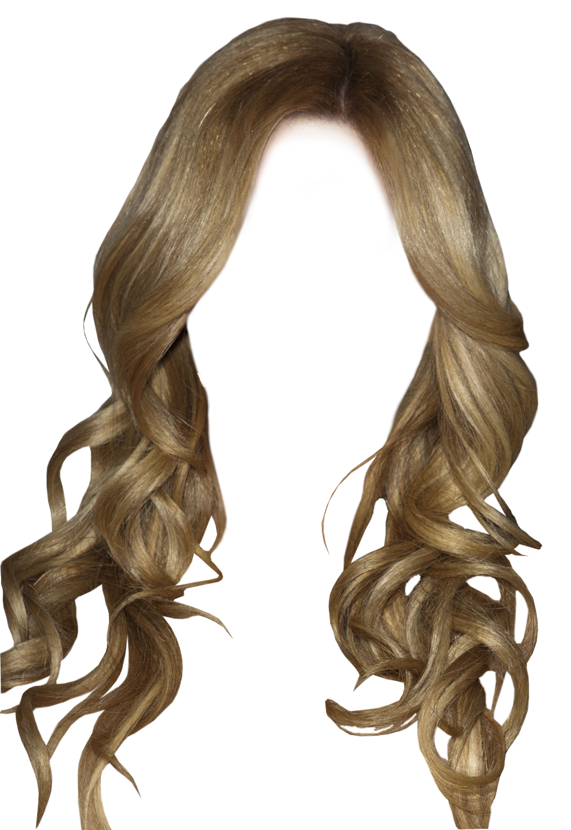

1. Mouth.
2. Nose.
3. Ear.
4. Hair.
5. Eyes.

|  |
| --- |
| **Questão 04** – **1,0 cada item = valor total 1,0** |

1. **Are you happy?**



1. Yes , I am.
2. No , I’m not.

|  |
| --- |
| **Questão 05 - 1,0 cada item = valor total 1,0** |

1. **Look! He is my _______.**



1. Father.
2. Mother.
3. Sister.
4. Brother.

|  |
| --- |
| **Questão 06 - 1,0 cada item = valor total 1,0** |

1. **Look ! this is my _______.**



1. Kite.
2. Robot.
3. Ball.
4. Car.

|  |
| --- |
| **Questão 07 - 1,0 cada item = valor total 1,0** |

1. **Look ! This is _____.**



1. My pencil.
2. My notebook.
3. My book.
4. My pen.

|  |
| --- |
| **Questão 08 - 1,0 cada item = valor total 1,0** |

1. **What’s your favorite color?**
2. It’s blue, yellow and Green.
3. It’s yellow book.
4. It’s pink pen.
5. It’s green leaves.

|  |
| --- |
| **Questão 09- 1,0 cada item = valor total 1,0** |

1. **Look! There is _______.**

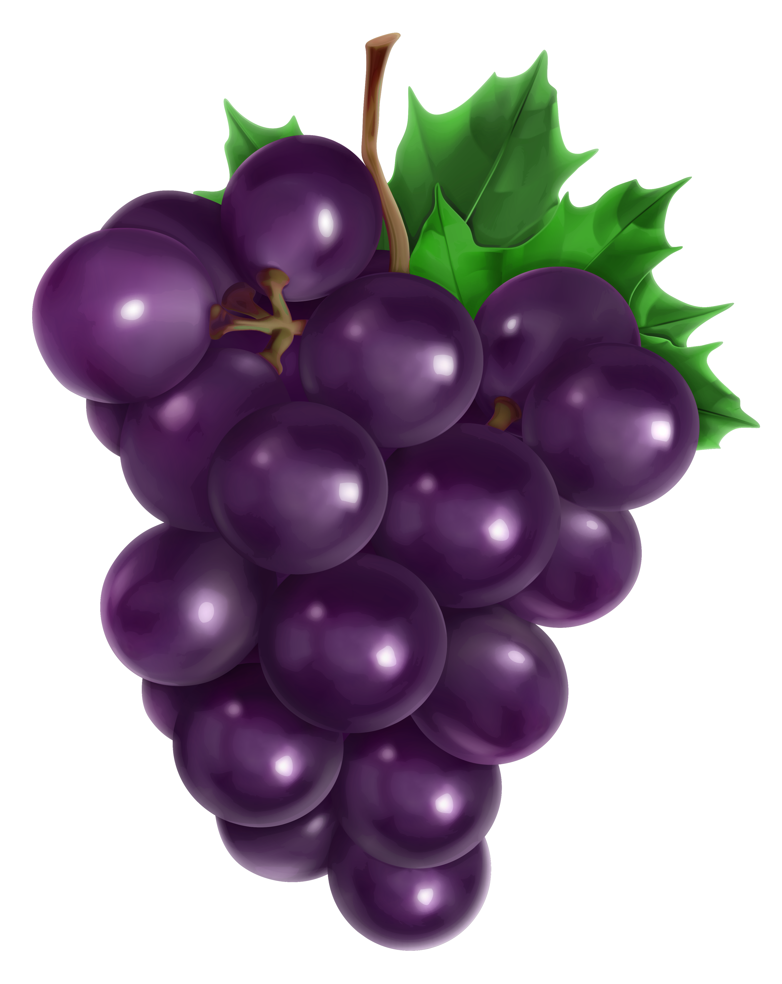

1. An apple.
2. A pears.
3. A grape.
4. An orange.

|  |
| --- |
| **Questão 10 - 1,0 cada item = valor total 1,0** |

1. **I have _______ whit ________ for breakfast.**
2. Salad ,rice.
3. Hot dog,carrot.
4. Beans ,soda.
5. Milk , coffee.

